**電通二乙微處理器實驗 實驗結報**

|  |  |  |  |
| --- | --- | --- | --- |
| **實驗名稱** | **Lab08** | | |
| **組別** |  | **組員** | **林楷桓** |

1. **實驗目的**

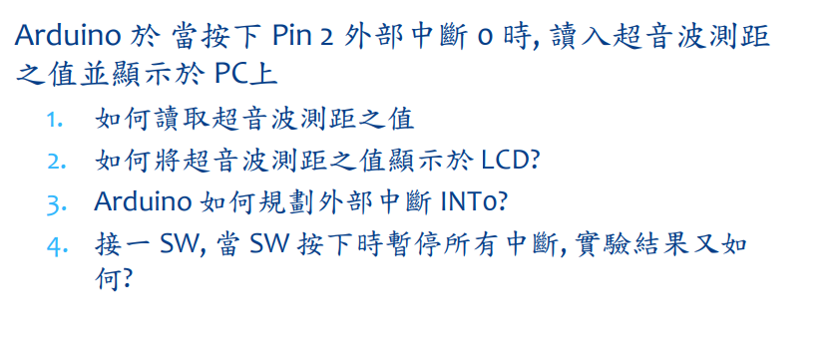

1. **實驗步驟**



1. **程式碼**

**01:**

**#include<Ultrasonic.h>**

**#include<LiquidCrystal.h>**

**#define TRIGGER_PIN 14**

**#define ECHO_PIN 13**

**LiquidCrystal lcd(12,11,5,4,3,10);**

**Ultrasonic ultrasonic(TRIGGER_PIN,ECHO_PIN);**

**void setup()**

**{**

**lcd.begin(16,2);**

**Serial.begin(9600);**

**}**

**void loop(){**

**float cmMsec,inMsec;**

**long microsec =ultrasonic.timing();**

**cmMsec = ultrasonic.convert(microsec, Ultrasonic::CM);**

**lcd.print("CM: ");**

**lcd.print(cmMsec);**

**delay(1000);**

**lcd.clear();**

**}**

**02:**

**#include<Ultrasonic.h>**

**#include<LiquidCrystal.h>**

**volatile boolean state=RISING;//initial value of switchp pin**

**#define TRIGGER_PIN 14**

**#define ECHO_PIN 13**

**LiquidCrystal lcd(12,11,5,4,3,10);**

**Ultrasonic ultrasonic(TRIGGER_PIN,ECHO_PIN);**

**void setup()**

**{**

**lcd.begin(16,2);**

**pinMode(2,INPUT_PULLUP);**

**attachInterrupt(2, int0,FALLING );**

**}**

**void loop()**

**{**

**}**

**void int0()**

**{**

**float cmMsec,inMsec;**

**lcd.clear();**

**long microsec = ultrasonic.timing();**

**cmMsec = ultrasonic.convert(microsec, Ultrasonic::CM);**

**lcd.print("CM: ");**

**lcd.print(cmMsec);**

**}**

**03:**

**#include<Ultrasonic.h>**

**#include<LiquidCrystal.h>**

**volatile boolean state=RISING;//initial value of switchp pin**

**#define TRIGGER_PIN 14**

**#define ECHO_PIN 13**

**LiquidCrystal lcd(12,11,5,4,3,10);**

**Ultrasonic ultrasonic(TRIGGER_PIN,ECHO_PIN);**

**void setup()**

**{**

**lcd.begin(16,2);**

**pinMode(2,INPUT_PULLUP);**

**attachInterrupt(2, int0,FALLING );**

**}**

**void loop()**

**{**

**if(digitalRead(6))**

**{**

**noInterrupts();**

**}**

**else**

**{**

**interrupts();**

**}**

**}**

**void int0()**

**{**

**float cmMsec,inMsec;**

**lcd.clear();**

**long microsec = ultrasonic.timing();**

**cmMsec = ultrasonic.convert(microsec, Ultrasonic::CM);**

**lcd.print("CM: ");**

**lcd.print(cmMsec);**

**}**

1. **實驗結果及分析**

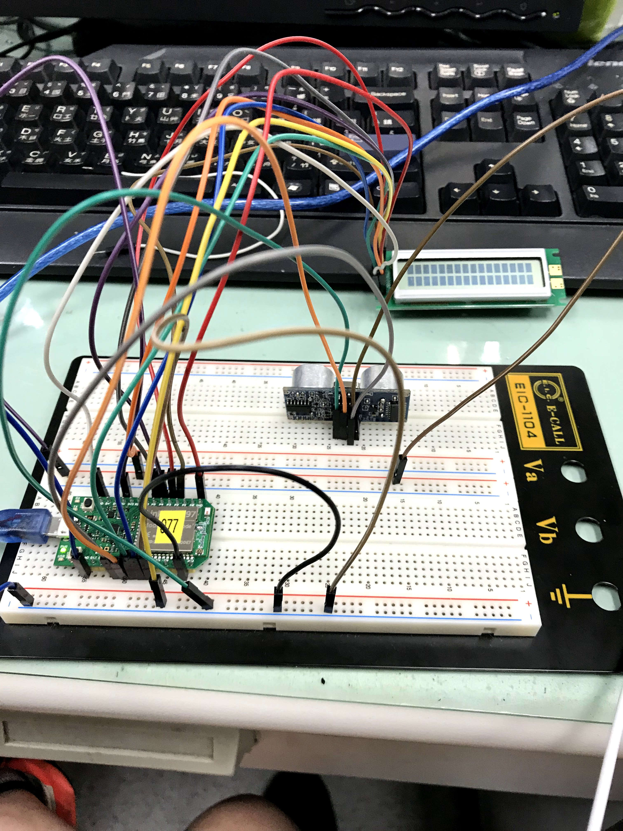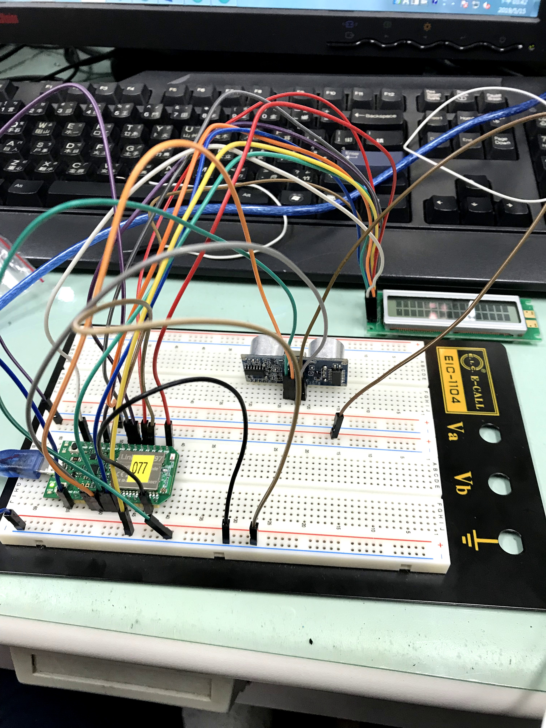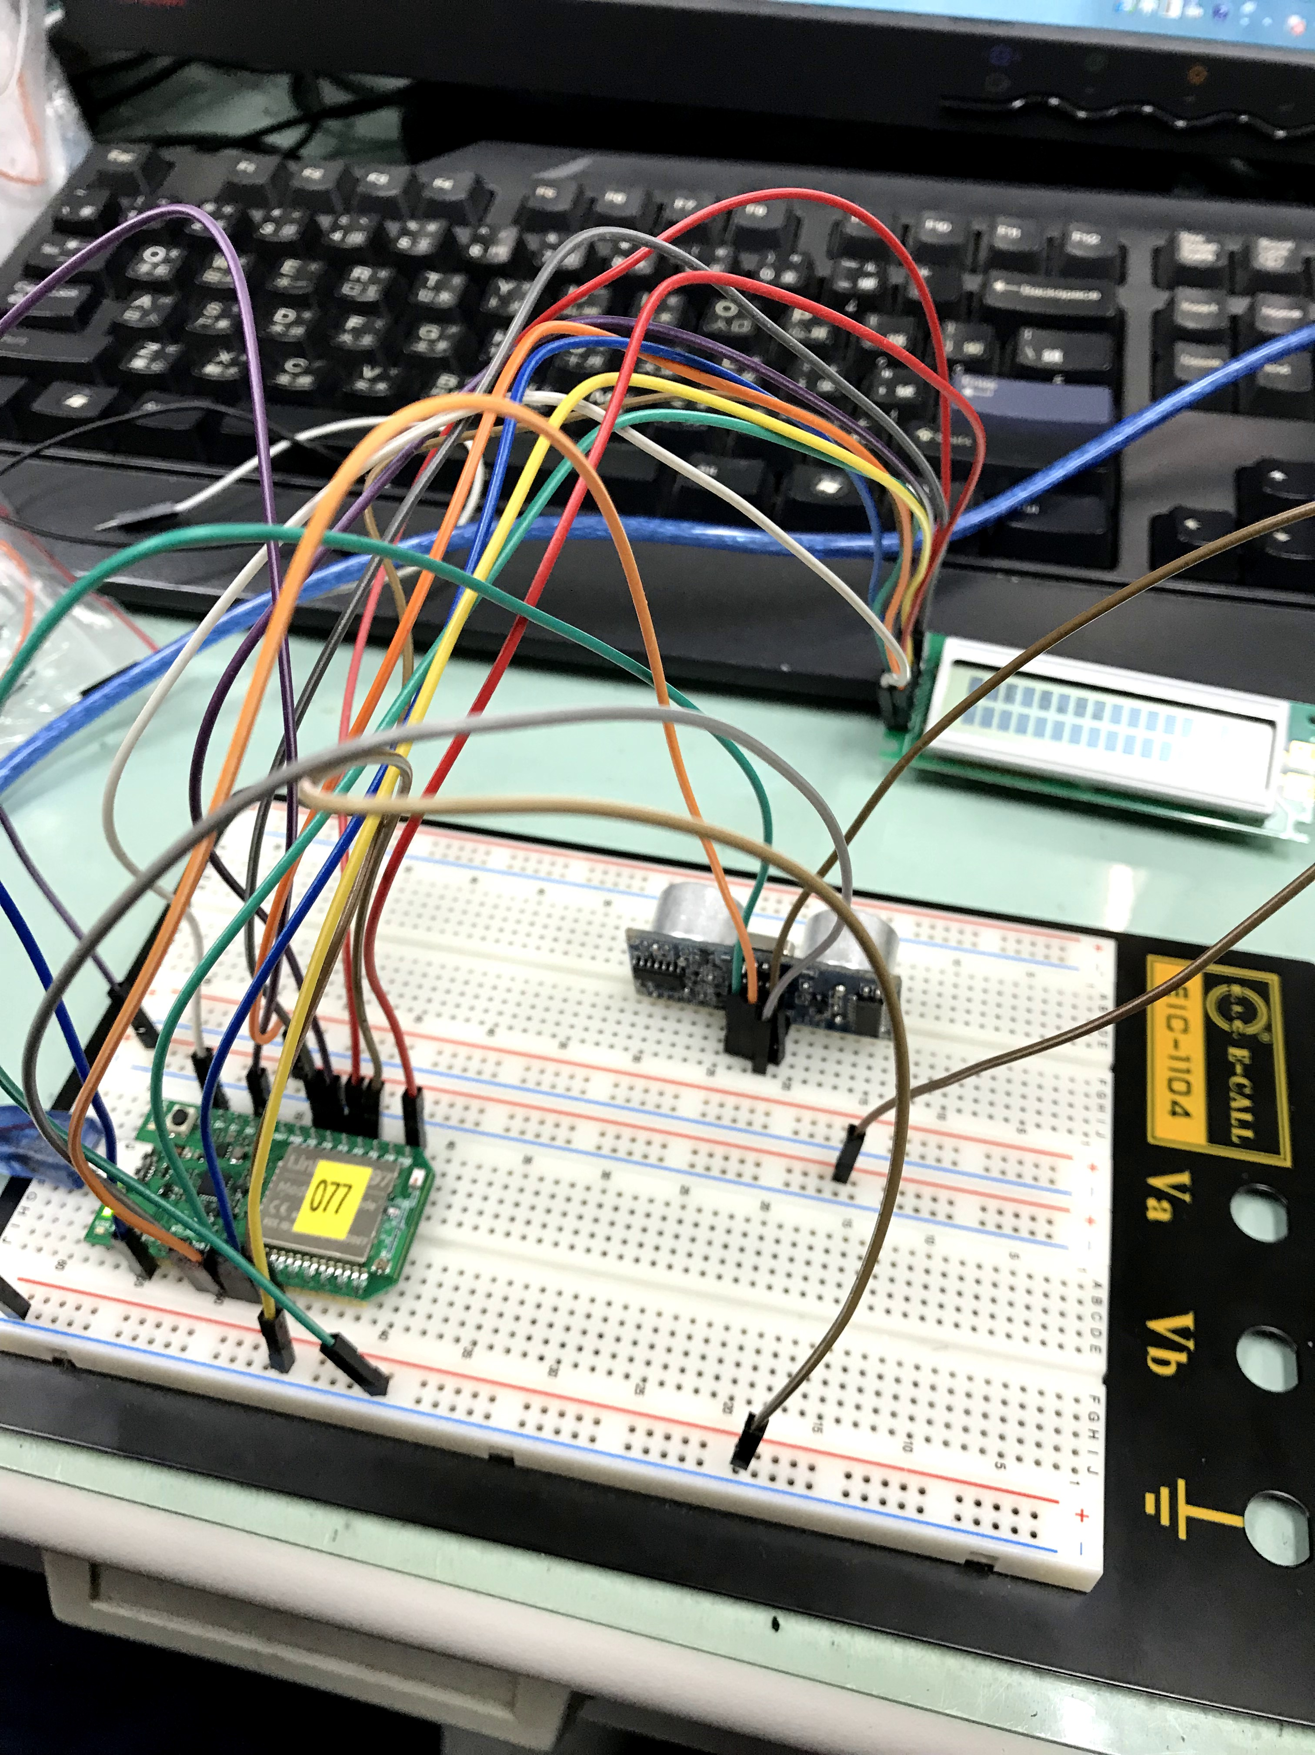

**5.心得討論**

**做上禮拜的**